Entity Relationship Diagram
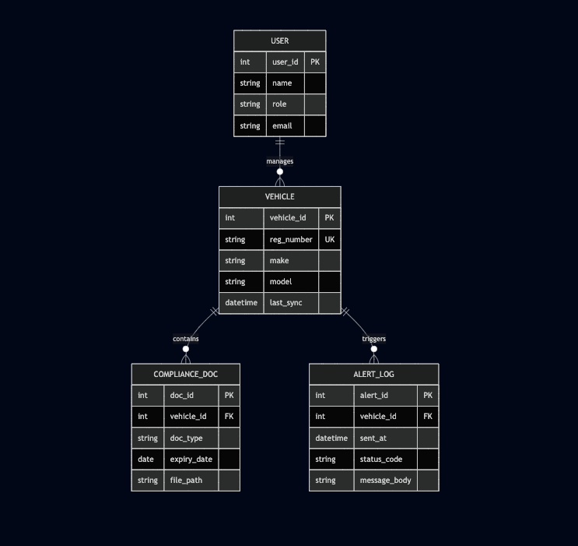

Data Dictionary
Field Name | Display Label | Data Type | Length/Format | Mandatory | Validation / Business Logic
vehicle_id | ID | Integer | N/A | Yes | Primary Key: Auto-incrementing. Internal use only.
reg_number | Registration No. | String | 10 chars | Yes | Unique: No duplicates. Regex: ^[A-Z]{2}[0-9]{2}[A-Z]{1,2}[0-9]{4}$. Auto-convert to uppercase.
make | Vehicle Make | String | 50 chars | Yes | Auto-populated by API. Dropdown fallback: [Tata, Ashok Leyland, Mahindra, etc.].
model | Vehicle Model | String | 50 chars | Yes | Auto-populated by API. Text input fallback.
ins_expiry | Insurance Expiry | Date | YYYY-MM-DD | Yes | Cannot be null. Used to calculate 'Days to Expiry'.
puc_expiry | PUC Expiry | Date | YYYY-MM-DD | Yes | Cannot be null.
fit_expiry | Fitness Expiry | Date | YYYY-MM-DD | Yes | Cannot be null.
doc_type | Document Type | String | Enum | Yes | Constrained to: ['RC', 'Insurance', 'PUC', 'Permit'].
file_path | Attachment | String | URL/Path | No | Must end in .pdf, .png, or .jpg. Max size 5MB.
last_sync | Last Sync Date | DateTime | ISO 8601 | Yes | System-generated timestamp of the last Vahan API fetch.

